Comprehensive School Improvement Plan

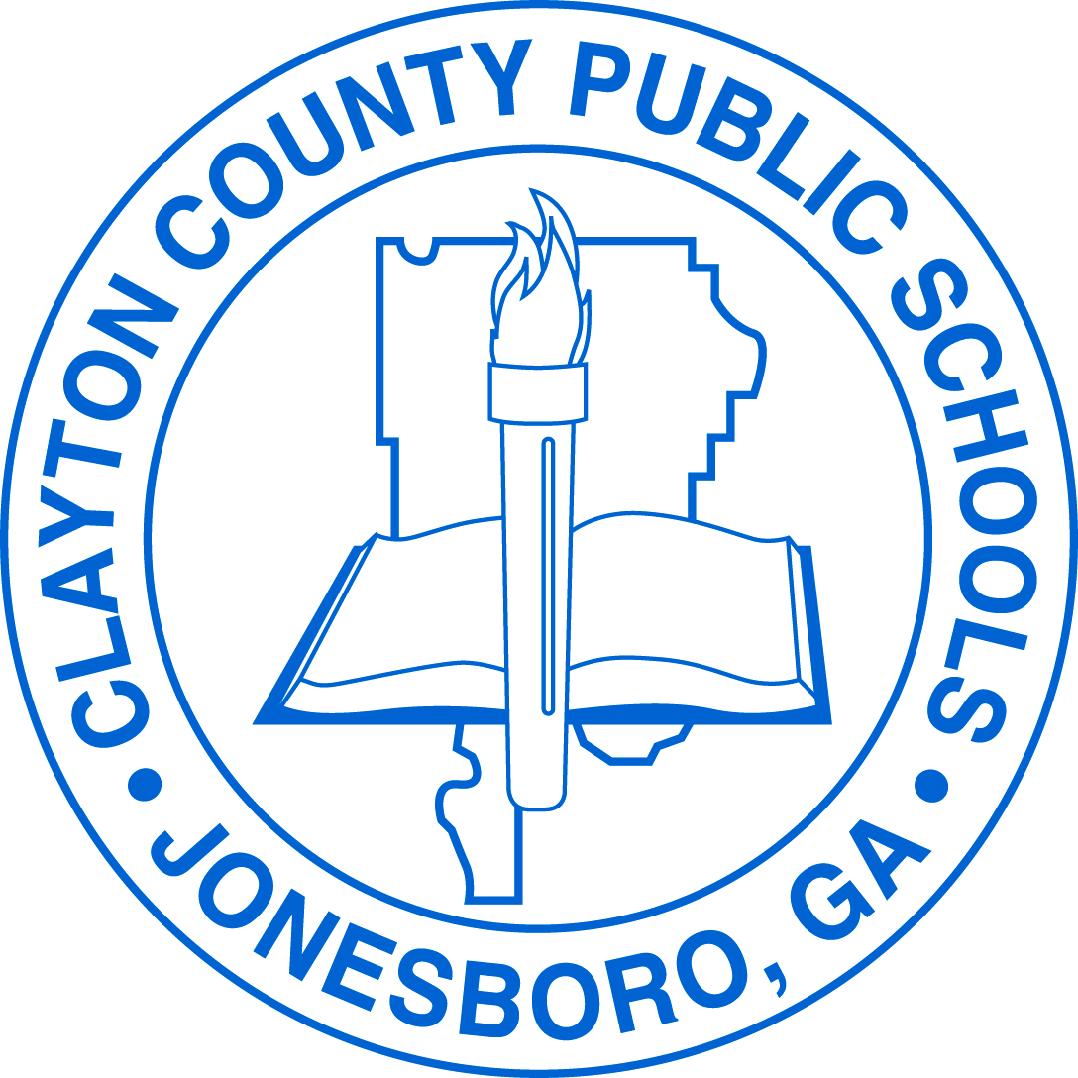

Rex Mill Middle School

2021-2022

Vision Statement
The vision of Clayton County Public Schools is to prepare ALL graduates to have the skills to pursue and successfully accomplish college, post-secondary training, and/or career opportunities in order to live and compete successfully in a global society.

Mission Statement
The mission of Clayton County Public Schools is to empower scholars to achieve academic, professional, and personal goals by providing equitable access and experiences that build skills in literacy, creativity, critical thinking, and collaboration.

Data

The MAP Growth assessment will be administered during the 2021-2022 school year and will serve as the primary data source for the Comprehensive School Improvement Plan. In lieu of CCRPI data, please include applicable data points based on your school’s level and designation. This data must be updated periodically based on the assessment calendar to reflect beginning, middle, and end of year data.

Data Profile Sheet: Rex Mill MS Data Profile

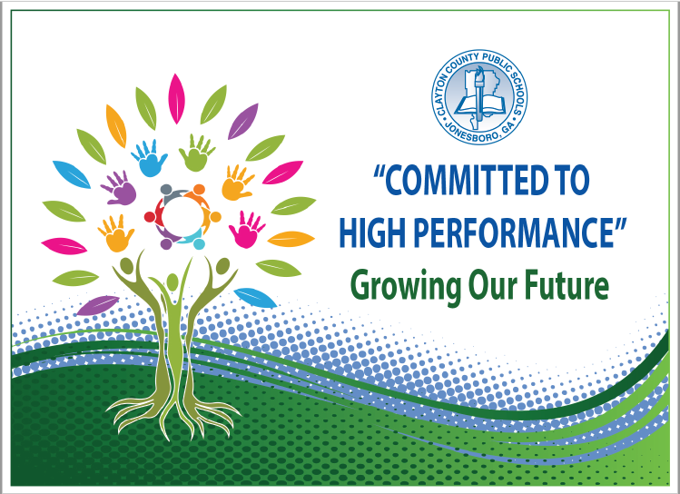
Strategic Goals
1. To increase and accelerate academic achievement in all content areas and literacy levels for all scholars, to include students in all special programs, in Clayton County Public Schools as evidenced by local, state, national, and international assessment results
2. To recruit, develop, and retain highly qualified and effective staff
3. To create an equitable and safe environment that promotes active engagement, communication, accountability, and collaboration of all stakeholders to maximize student achievement
4. To provide high quality, equitable support services delivered within budget to promote high performance in the Clayton County Public Schools
5. To create and assess equity metrics that include dedicated resources, both fiscal and human capital, instructional programming, organizational structures, policies, etc.
6. To establish a creative district where scholars and the community have access to the arts and cultural experiences and resources that support collaborative and individual creative pursuits

Action Plan

Performance Objective 1: By 2023, Clayton County Public Schools will demonstrate three percentage points growth each school year, for students scoring at the proficiency levels as evidenced by state, national, and international assessments.
GADOE School Improvement Systems: Coherent Instruction, Effective Leadership, Family and Community Engagement, Professional Capacity
Action Steps/ Tasks  Consider action steps/tasks that support a face-to-face learning environment and/or a remote learning environment. | Timeline | Project Leader(s) and School Level Person(s) Monitoring | Resources/ Funding | Check Points/ Related Artifacts and Evidence | Professional Learning  Activity and Date  (where applicable)

Create lesson plans incorporating STEM units and Design Thinking using the feedback from instructional leaders and vetted resources that support acceleration / advancement | August, 2021 - May, 2022 | Administrators  Academic Coaches  Department Chairs | Local | Weekly highlights of well written plans utilizing Design Thinking frameworks and STEM units with embedded resources/changes highlighted using a standards-based rubric to guide feedback and resources  https://www.dickinsonstate.edu/Assets/uploads/files/departments/teachered/DSU%20Lesson%20Plan%20Rubric%20-%2005-12-2017.pdf  http://www.greengineers.org/uploads/9/2/9/0/9290081/dt_basic_guide___rubric.pdf  Participate in collaborative planning twice a week with standards, deconstructed standards, resources and pacing guide with Quad D task  Goal 90% of teachers able to produce standards based lesson plans incorporating Design Thinking on a consistent basis | PL Sept. 2021--Feedback Academic Coaches  Model lesson plan writing per department  Review rubric  August, 2022  Review of lesson plan writing per department November, 2021  September, 2021; November, 2021; January, 2022; May, 2022 Departments write STEM units and revise current STEM units

Supplemental Supports: What supplemental action steps will be implemented for these subgroups?
Economically Disadvantaged | Foster and Homeless
Some materials will be available for students to complete STEM projects/water tower projects  Explicit modeling in smaller groups | Some materials will be available for students to complete STEM projects/water tower projects  Explicit modeling in smaller groups
English Learners | Migrant
Explicit modeling in smaller groups  Projects supported/completion in ESOL pullout  Translated directions/verbally speak with parents using the international center translator or in-house to explain the projects and purpose  Instructional videos and recorded lessons available on canvas | Some materials will be available for students to complete STEM projects/water tower projects  Explicit modeling in smaller groups  Recorded lesson available on Canvas
Race/Ethnicity/Minority | Students with Disabilities
Some materials will be available for students to complete STEM projects/water tower projects  Explicit modeling in smaller groups | Explicit modeling in smaller groups  Support after school for projects as needed  Explicit modeling in smaller groups  Recorded lesson available on Canvas

Performance Objective 2: Over the next five years, Clayton County Public Schools will increase the graduation rate from 69.6% to 90% or higher.
GADOE School Improvement Systems: Coherent Instruction, Effective Leadership, Family and Community Engagement, Professional Capacity
Action Steps/ Tasks  Consider action steps/tasks that support a face-to-face learning environment and/or a remote learning environment. | Timeline | Project Leader(s) and School Level Person(s) Monitoring | Resources/ Funding | Check Points/ Related Artifacts and Evidence | Professional Learning  Activity and Date  (where applicable)

Increase the number of students participating in Honors and advanced track courses | August, 2021 – May, 2022 | Administrators  Academic Coach  Department Chairs  Science Teachers  Math Teachers | Local | Identify 6th – 8th grade students maintaining a 4.0 GPA first 9 weeks in Math and Science  Identify students who are excelling in scientific thinking in the 6th and 7th grade  Identify students who are excelling in algebraic thinking in 6th and 7th grade | October, 2021  Collaborative Planning (weekly)
Increase the number of students who will participate in HS career / college tracks | December 2021 | Counselors  Administrators  Department Chairs  Student Engagement Specialist | Local | Using town hall meetings and designated days to meet with 8th grade students about the type of course tracks offered in high school.  Meet with 8th grade students in high school courses to identify their individual needs | Collaborative planning with 8th grade  PD utilizing resources available for students to get support in HS credit courses to encourage “productive struggle”

Supplemental Supports: What supplemental action steps will be implemented for these subgroups?
Economically Disadvantaged | Foster and Homeless
Monitor grades each grading period  Identify available options and resources for support  Expose students to various STEM careers | Monitor grades each grading period  Identify available options and resources for support  Expose students to various STEM careers
English Learners | Migrant
Monitor grades each grading period  Identify available options and resources for support  Expose students to various STEM careers  Translated directions/verbally speak with parents using the international center translator or in-house to explain Honors and advanced/accelerated courses | Monitor grades each grading period  Identify available options and resources for support  Expose students to various STEM careers
Race/Ethnicity/Minority | Students with Disabilities
Monitor grades each grading period  Identify available options and resources for support  Expose students to various STEM careers | Monitor grades each grading period  Identify available options and resources for support  Expose students to various STEM careers  Review IEPs and re-evaluations for strengths

Performance Objective 3: By 2023, Clayton County Public Schools will increase the number of students absent less than 10% of their enrolled academic year.
GADOE School Improvement Systems: Effective Leadership, Supportive Learning Environment, Family and Community Engagement, Professional Capacity
Action Steps/ Tasks  Consider action steps/tasks that support a face-to-face learning environment and/or a remote learning environment. | Timeline | Project Leader(s) and School Level Person(s) Monitoring | Resources/ Funding | Check Points/ Related Artifacts and Evidence | Professional Learning  Activity and Date  (where applicable)
Monitor attendance for 3 days; 5 or more days | August, 2021 – May, 2022 | Registrar  Counselors  Social Worker | Local | Monthly report of student absences | District PD to Registrar and Counselors August, 2021
Conduct SAC/COS for students with 5 or more absences and follow county protocol (Identify if student absences are Hospital Homebound/ Quarantined/ Virtual) | September, 2021 – May, 2022 | Registrar  Counselors  Social Worker  COS  Student Engagement Specialist  Administration | Local | Attendance letters following district protocol  Follow-up with COS to ensure students do not need further support/resources (agendas) | District PD to Registrar and Counselors August, 2021
Provide incentives for perfect attendance and 100% engagement (missing 0 assignments) each 9 weeks | October, 2021, January, 2022, March, 2022 and May, 2022 | Parent Liaison  ISS Facilitator  Student Engagement Specialist  PBIS coach | Local | Monthly PBIS incentive  Academy Incentives  Academic Recovery every 4.5 weeks/8 week per grading period | N/A
Provide weekly support to students identified as at risk | October, 2022 - May, 2022 | ISS facilitator  COS  Student Engagement Specialist  PBIS Coach  front office  parapros  Administration | Local | Academic grades 9 weeks and 4.5  attendance  Phone calls/emails  Small Groups | N/A

Supplemental Supports: What supplemental action steps will be implemented for these subgroups?
Economically Disadvantaged | Foster and Homeless
Monitor student attendance | Monitor student attendance  Include SW to assist in making contact
English Learners | Migrant
Monitor student attendance  Communicate using interpreters | Monitor student attendance
Race/Ethnicity/Minority | Students with Disabilities
Monitor student attendance | Monitor student attendance  Include case manager and DES chairperson

Performance Objective 4: By 2023, Clayton County Public Schools will decrease the number of discipline infractions while increasing employee morale and community support.
GADOE School Improvement Systems: Effective Leadership, Supportive Learning Environment, Family and Community Engagement, Professional Capacity
Action Steps/ Tasks  Consider action steps/tasks that support a face-to-face learning environment and/or a remote learning environment. | Timeline | Project Leader(s) and School Level Person(s) Monitoring | Resources/ Funding | Check Points/ Related Artifacts and Evidence | Professional Learning  Activity and Date  (where applicable)
Observe student of the month luncheon per team | August, 2021 – May, 2022 | Administrators  Teachers  PBIS Coach  Student Engagement Specialist | Local | Student Recommendations | N/A
Observe teacher of the month per academy | August, 2021-May, 2022 | Administrators  PBIS Coach  Student Engagement Specialist | Local | Teacher Recommendations | N/A
Implement clubs virtually during the school day (Pulse Hour) | September, 2021 – April, 2022 | Administrators  Teachers PBIS Coach  Student Engagement Specialist | Local | Sponsorship  Club enrollment  Pulse Hour monitoring | N/A
Identify students with chronic discipline in COS | September, 2021 – April, 2022 | Administrators  COS team  PBIS Coach  Student Engagement Specialist | Local | Identified students as chronic discipline and monitor discipline record with further support as needed (Behavior interventionist, ACES) | Review of Virtual Discipline Plan, September , 2021
Facilitate daily SEL activities | August, 2021-May, 2022 | Counselors  SEL Committee PBIS Coach  Student Engagement Specialist | Local | Connections teachers will utilize the CCPS SEL Scope and Sequence using the ReThinkEd website.  Homeroom teachers will utilize an SEL template that is customized to each content on a daily basis. | N/A

Supplemental Supports: What supplemental action steps will be implemented for these subgroups?
Economically Disadvantaged | Foster and Homeless
Write positive affirmations regarding specific behaviors | Write positive affirmations regarding specific behaviors  Refer to ACES
English Learners | Migrant
Write positive affirmations regarding specific behaviors  Acknowledge a variety of cultures (Spanish Heritage; Black History; Chinese New Year) | Write positive affirmations regarding specific behaviors
Race/Ethnicity/Minority | Students with Disabilities
Write positive affirmations regarding specific behaviors  Acknowledge a variety of cultures (Spanish Heritage; Black History; Chinese New Year, Women’s History) | Write positive affirmations regarding specific behaviors  Refer to ACES

